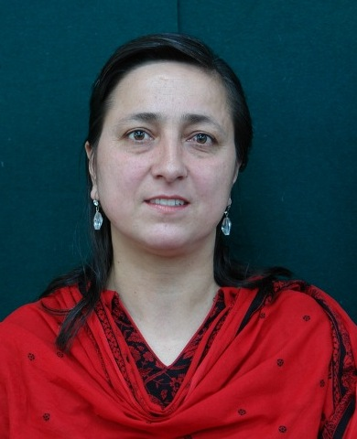

Presenter’s Profile
Ms. Khush Funer Murtaza completed her M.Ed. (Teacher Education) from the Aga Khan University-Institute for Educational Development (AKU-IED) Karachi. She also holds an MA. degree in Education and International Development from Institute of Education-University of London UK. Earlier, she was engaged in teaching and in leadership role at Aga Khan Education Services for Pakistan (AKESP). Currently she is in the process of Doctorate in Education (EdD) from Open University UK. After completion her M. Ed. she is associated with the Aga Khan University-Professional Development Centre North (AKU-PDCN) and is working as Senior Instructor. She has a very rich experience of teaching and teacher education. Her special area of research interest includes early childhood education and development, English language teaching, leadership and management, school improvement, and teacher development. She has presented her research in national and international conferences and has published her work in international journals.

Presentation Outline
- Introduction of AKU-PDCN
- Importance of Reading in Early Years
- RfC Libraries (i.e. School Library in Project Schools and Community Library)
- Number of Storybooks Issued
- Project Beneficiaries
- Project Coverage Areas
- RfC Outcomes
- Impact of Reading for Children (RfC)
- Way Forward

